**FIRST CRY**

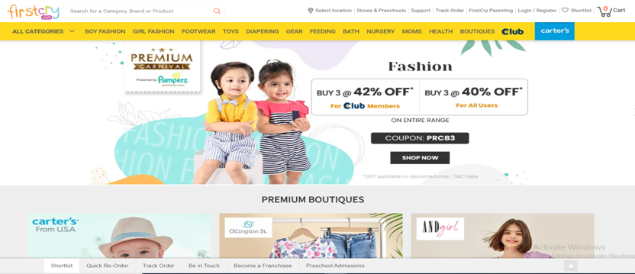

**Overview:**

It is an E-Commerce website meant only for kids; here all kind of baby products are available. From A to Z all baby requirements are covered in this Website. The main object of making this E-Commerce website is to help parents in search of Baby products.

**Home Page:**

This contains Header, Footer section and Logo of the website. Some Coupon codes will be displayed with Banner part. Brands also will be displayed in this page.

**Registration Page:**

Here customers can login from this page to website. In this small validation will be there like checking username & Password matching from DB.

**Main Page/ Product Listing Page:**

This is the main page of website because it contains all product information. Here we will be having filter option (price range, size, sorting). In the right side of page we have products listed according to filter options. Product image with name and price will be displayed with wishlist icon and add to cart button.

**Product Details Page/PDP:**

In this page we show product details which is selected by customer. We show here products images, name, description and all details of the particular product with wishlist & Add to cart button.

**Wishlist Page:**

In this page we will list all the products selected by customer as wishlist.

**Payment Page:**

This is also one of the most important pages. Here payment section will be there. Customer can select payment method to pay for orders.

**Simple FlowChart :**

Home Page 🡪 Login/Registration Page 🡪 Home Page 🡪 PLP 🡪 PDP 🡪 Cart Page 🡪

Payment Section 🡪 Thanks Message.